Thank you
Thank you very much for your support, enabling Stretch Didcot to hold a second Greek and Roman Festival. Once again, we received a great many positive comments and return visitors.

Objective
The objective of the group is to organise fun and educational events for the local community.
Once again, we had very enthusiastic visitors who were delighted to be learning from those so knowledgeable about their subject.

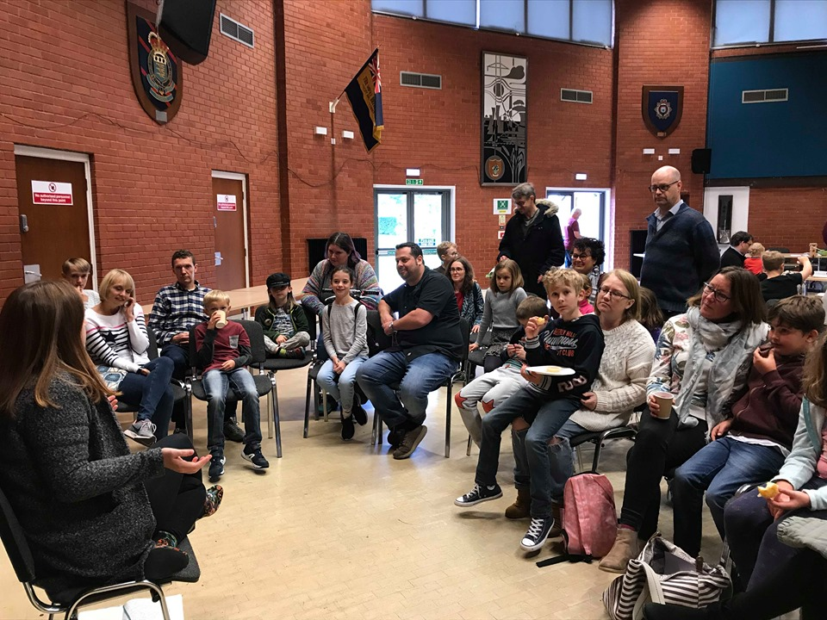
Marchella Ward, Classics Outreach, University of Oxford

Community Engagement
We had a real cross section from society. This year the event was free so this enabled wide participation from every socio-economic group. Approximately 600 people attended throughout the day, from opening to closing.
We had an honesty box for food – we made a small profit from this, as we didn’t wish to profit from ‘essentials’ like tea and coffee.
Our venue – our town Civic Hall – is accessible. We had a few visitors in wheel chairs and many push chairs. All events were on the ground floor – an improvement from last year.
At the last minute our mosaicist was unable to come, however he was able to courier all materials over to us. The community group enlisted support from a well-known local mosaicist (who assisted Laurence last year) and also an art teacher. They were delighted to work together and enjoyed the day.
Our activities appealed to a cross section of ages. Many children were interested in the Roman Slinger’s work, although all workshops were accessible to everyone – apart from the drama workshop.
A member of the community volunteered her time to create Roman planets/ gods and goddesses activity. This was very engaging for the children who took part in it.
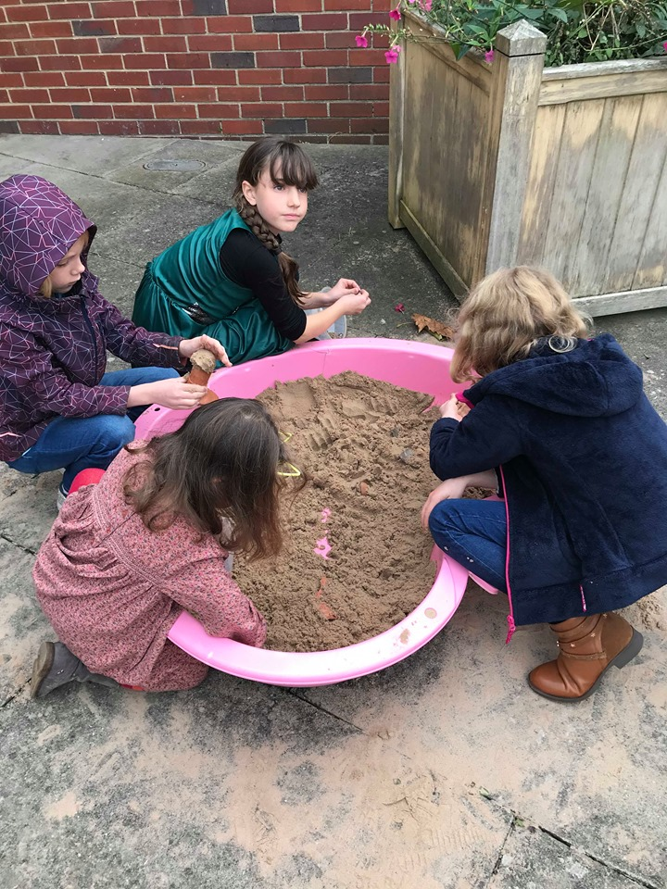
Children enjoying finding buried artefacts, loaned by Wallingford Museum
(Sandpit loaned by a Didcot resident).
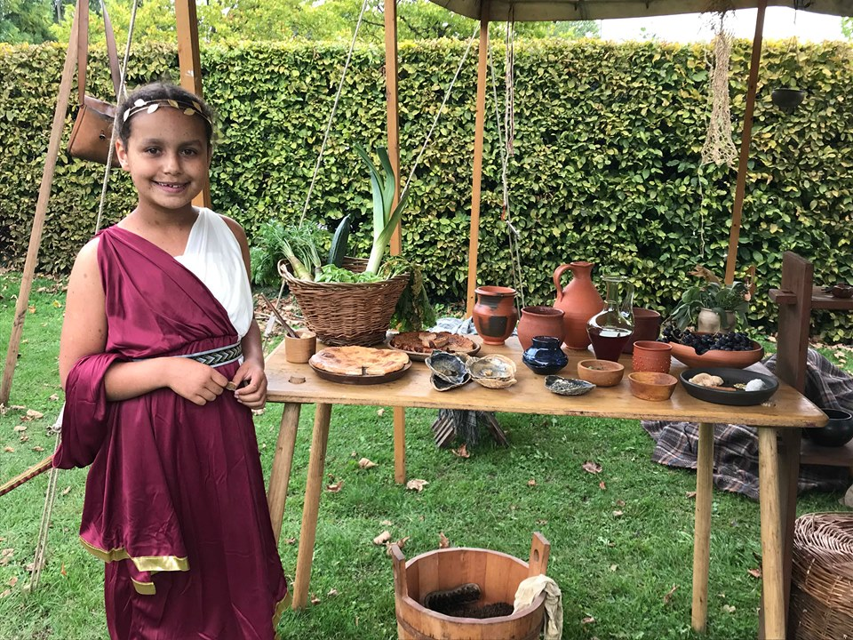
An enthusiastic guest, at the Roman Cook’s table

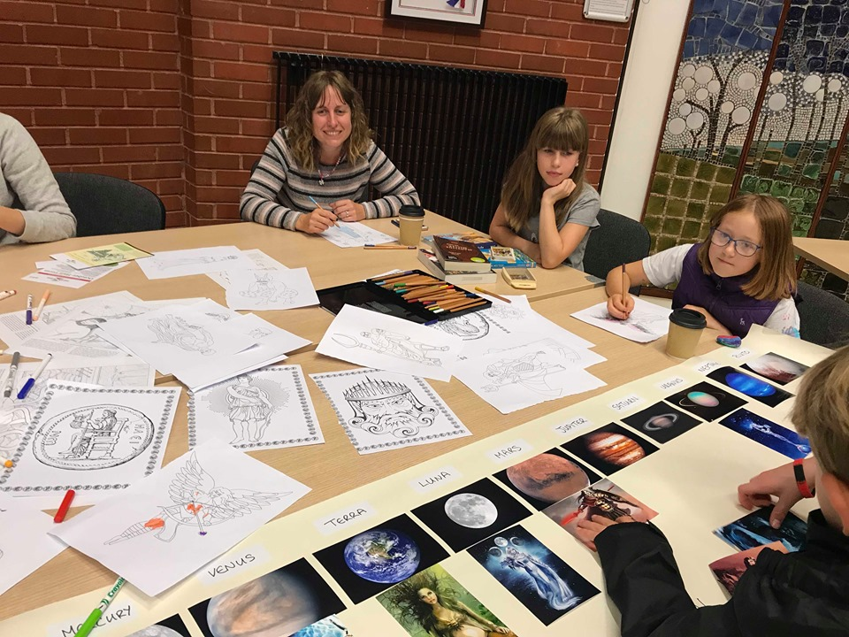
Children enjoying the myth table, run by a volunteer

Committee Members
Once again, our committee members and volunteers for the day all had much to offer. Our qualified accountant has been invaluable, a qualified art teacher and mosaic expert standing in. We recruited volunteer restaurant workers holding food hygiene certificates to do the food and our Chair took an on-line hygiene certificate.

Building Community Connections
Our replacement mosaicists have plans to work together on future projects. This is very exciting as both are passionate about engaging children.
Our Chair, Melissa Mallows, was asked to contribute to a research project into Dr Nevin’s work on the Panoply Vase Animation Project for the Knowledge Exchange team at the University of Oxford, in particular people’s reaction to her work.
Several local teachers attended with their families – we are hoping that this will encourage further connections with local schools. It is particularly difficult to engage with schools, despite both the Greeks and the Romans being covered. Those schools who were studying the Greeks did include our information in their newsletters, but help in publicising the event appears to be highly dependent upon the interest of the person receiving the email. One school administrator had just finished the Open University Classical Studies degree and so was keen to include the information in their weekly newsletter. This subjectivity is difficult to manage because it is so arbitrary.
We did not have a Myth Competition this year. In part this was due to not receiving book sponsors like we did last year.
We have had people asking if there will be another festival in 2020 because they enjoyed the day so much.

Our Experts
This year we had:
- A Roman Slinger
- A blacksmith
- A Roman Cook
- Two Greek vase animators
- A Roman Mosaic
- Abingdon Museum, with Roman artefacts
- The Earth Trust, displaying Roman artefacts from Wittenham Clumps
- A Greek drama workshop provided by a local children’s drama company.
- A talk about his find of the Roman Villa in Broughton Castle grounds by Keith Westcott of the Proposed Metal Detectors’ Association
- A talk by Marchella Ward, outreach Classicist from the University of Oxford, about myth. This was extremely engaging for young and old alike!
- A talk by Bill Darley, who found the Aureus gold with a metal detector on the site of a new housing estate in Didcot.
- Borrowed artefacts from Wallingford Museum, for a sandpit treasure.

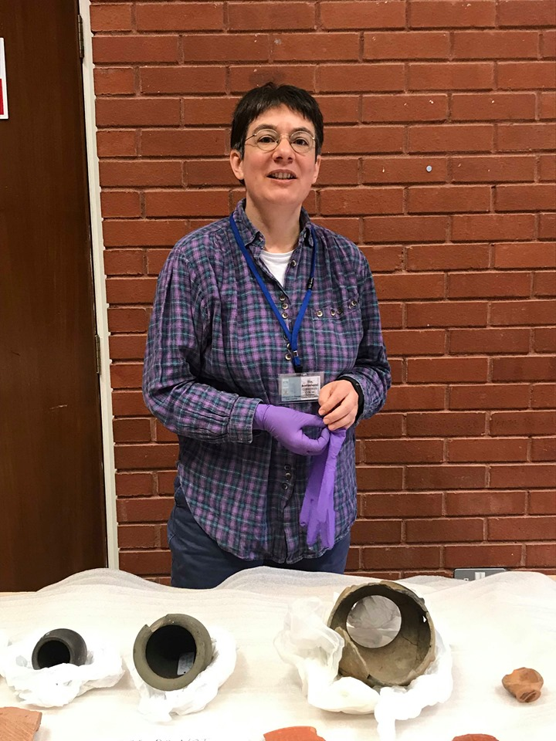
Elin Bonemann, Abingdon Museum

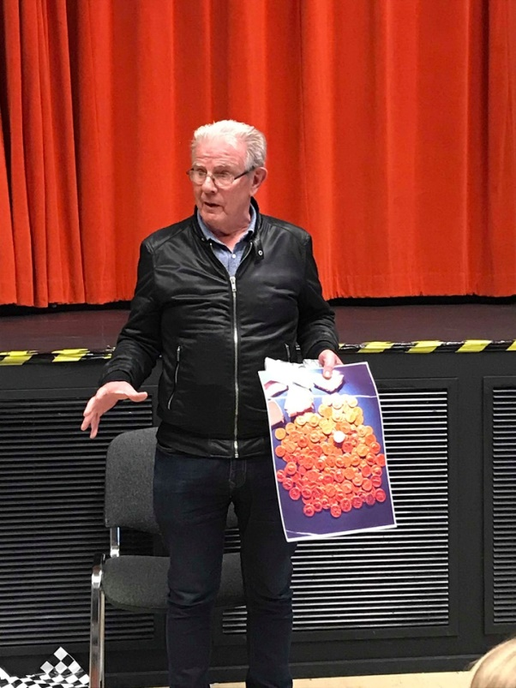
Bill Darley – holding a photo of the Aureus Gold he discovered with a metal detector

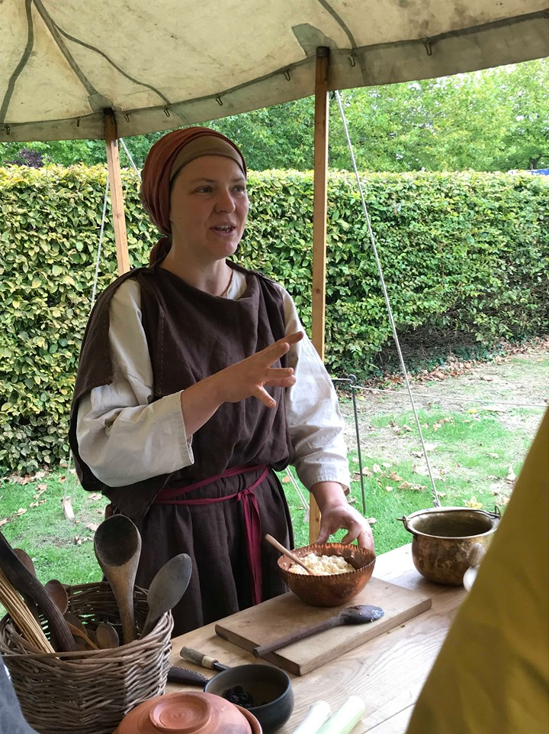
Caroline Paro - Roman cook
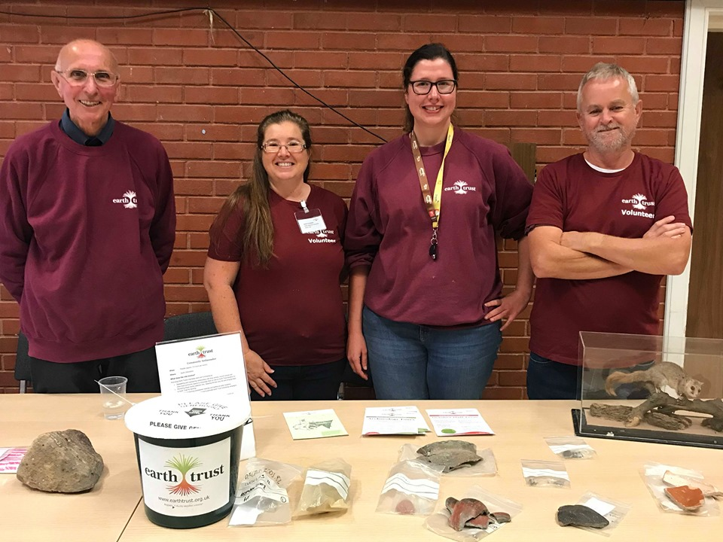
Earth Trust volunteers
Sadly:
- Our Civic Hall was double booked and our festival had to be pushed back to 5th October. This meant that the following people were unable to come:
- Laura Jenks, of Greek Myth Comix fame
- Children’s myth writer Maz Evans
- Cheney School’s The Irish Project
- Dr Zena Kamash from Royal Holloway
In addition, Dr Claudina Romero Mayorga from the University of Reading’s Ure Museum was working at their Classics Open Day so also couldn’t come.
- The Donkey Sanctuary forgot to log our request for a visit and so their volunteers took a holiday.
- Our Roman soldier had twisted his knee and was unable to come at (literally) the 11th Hour!
None of these absences, although unfortunate, took away from the day and we remain very grateful for the time volunteers gave up to visit us and the effort those with activities and stands put in to travel to us and present/ talk.

Social Media Connections
The blog ‘Mums of 2.4 Children’ and also ‘In Didcot’ helped spread the word about our festival. We were most grateful for their help.
In addition, this year we paid for a website for a few months. This was far more effective than the Gmail blog we used last year which is attached to our Gmail email account. Our website was shared on local parenting Facebook pages and local village Facebook groups.

Networking
Relationships with our visiting experts continue and have expanded. Our Roman Slinger, mosaicist, blacksmith and vase animators all returned.
Keith Westcott and Bill Darley got on marvellously and exchanged contact details. This was very pleasing.

Money Raising Opportunities Arising from your financial help
Last year the committee applied for our community group to be a beneficiary of the South Oxfordshire community lottery. This year we raised £213.50 which paid for our website hosting fees and associated costs.
We did not charge entry for this year’s festival as one of the conditions of being granted the Tesco Bags of Help was that entry be free. This was also the aim for 2019 and I am pleased that we managed it.
Grants in Total: £2, 200.

Future Events
Stretch Didcot’s aim is to put on festivals with different themes. A couple of our members have Indian continent connections and are interested in hosting a cultural evet. Our Roman slinger is also very keen on the Vikings.

Conclusion
2019’S festival built on the successes of 2018’s. This was helped by the different choices we made re: location and time of year. Not charging an entrance fee was morally preferable for us and this is the model we would like to follow in the future.

Thank you for your financial assistance, which helped us to bring more fun - and knowledge- to Didcot.

The Committee of Stretch Didcot, Community Group

