Funding Report
Thanks to the generous support of the Dover Fund, provided by the Society for the Promotion of Hellenic Studies, I was able to make significant contributions to the project entitled “Towards a Performance-Led Approach for Teaching of Greek Drama in Secondary Schools,” led by Dr Emmanuela Bakola.
Over the past 12 months, the project has developed in multiple ways, with there currently being over 30 bitesized resources available for use by A-level students on the website (https://greektheatrewarwick.co.uk/resources/?_type_of_resource=bitesize). My contributions to this project have included maintaining the website on a weekly basis while simultaneously conducting independent research on ancient Greek theatre and its performance. This research has been made available for students through the aforementioned bitesized resources, which are visually engaging short videos that help student appreciate the various levels of performance present in ancient texts. Some of the bitesized resources that I have produced during this time include the videos titled: “The Role of the Chorus in Sophocles’ Oedipus Tyrannus,” “‘Why join the sacred dance?’ Metatheatricality and the chorus in Oedipus Tyrannus,” “The Role of Minor Characters in Sophocles’ Oedipus Tyrannus,” and “Antigone As A Bride of Death in Sophocles’ Antigone (lines 806-943)” (to be released on YouTube).
At the same time, I have also managed supplementing each bitesized video with a multiple-choice quiz in order to enhance the learning and understanding of students who engage with these resources. This work includes both reviewing and uploading the quizzes made by other contributors while also making quizzes of my own. The inclusion of these quizzes enables the bitsized videos to be considered for endorsement by the Cambridge OCR. By becoming endorsed by the OCR, the project would be able to greatly increase its range of influence among students, making them a vital addition to the project.
Once again, I am immensely grateful for the generous support of the Hellenic Society in contributing to this project and its impact on students.
Almila Dükel
University of Warwick

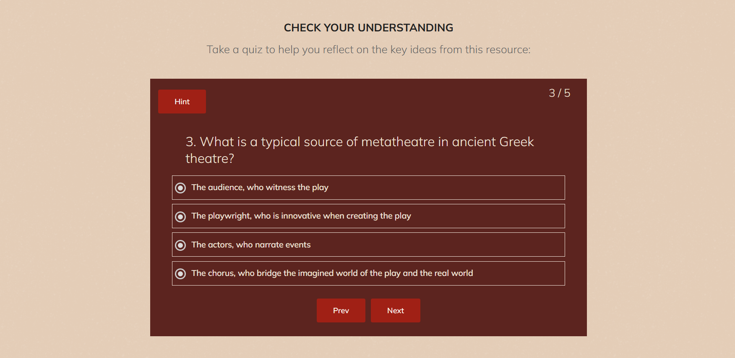
An example of the quizzes made for the Greek Theatre at Warwick website.

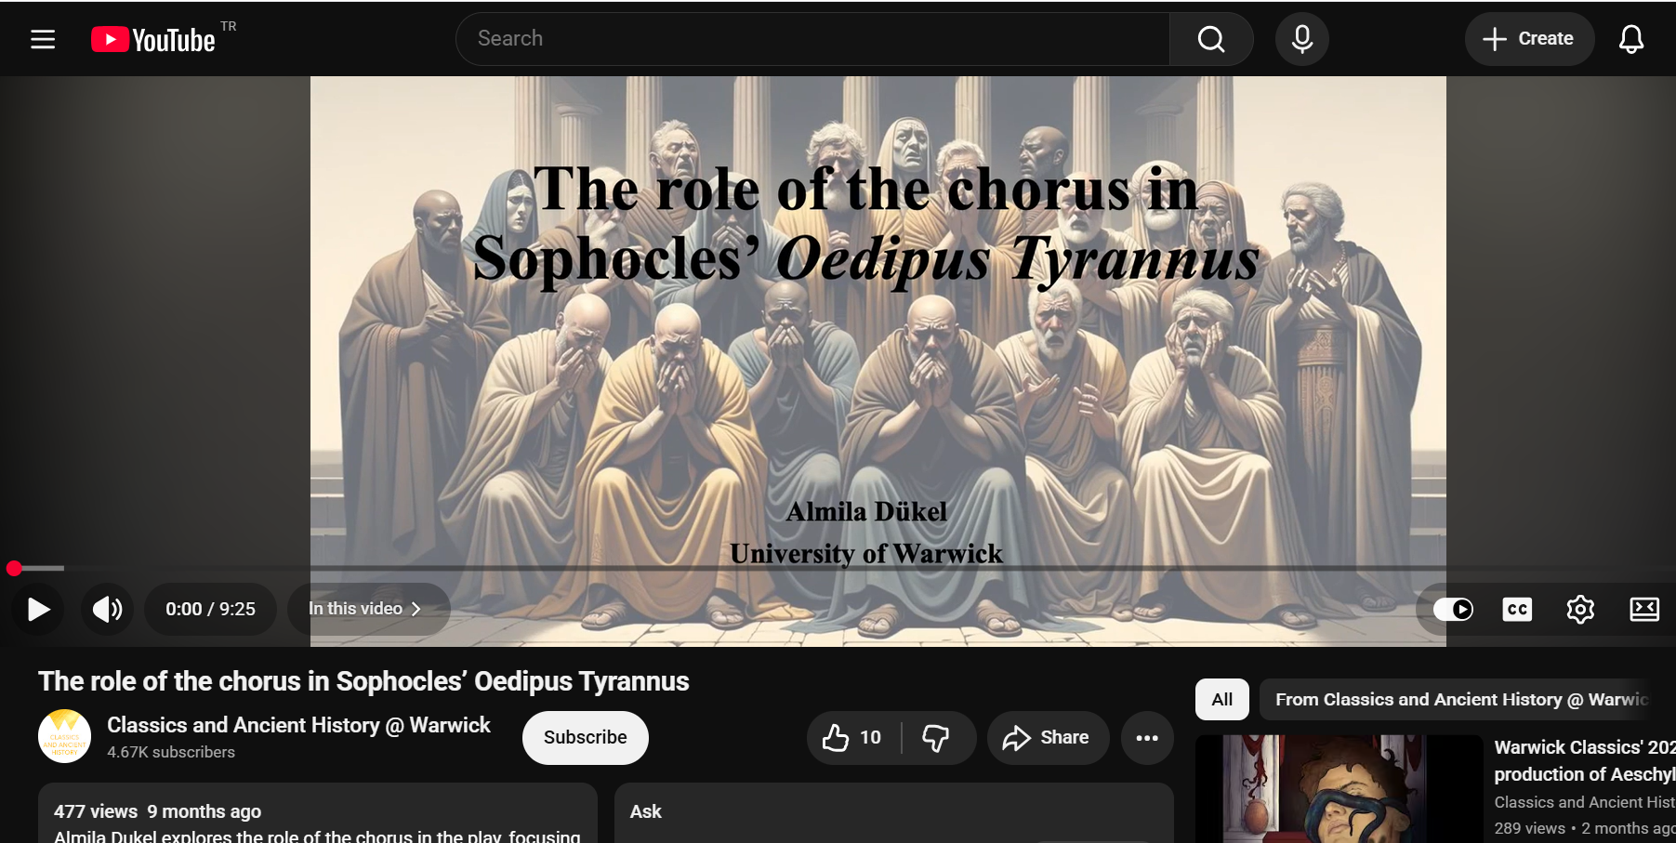
An example of the bitesized resources made for the project.

